For research article
Response to Reviewer 1 Comments
Point-by-point response to Comments and Suggestions for Authors
Comments 1: There is only one large flow chart in this paper, which is monotonous. It is recommended that each module be shown in detail with diagrams.
Response 1: We sincerely thank the reviewer for this constructive suggestion. We fully agree that presenting the overall framework and the specific details of all sub-modules in a single diagram compromised readability and made the visual presentation monotonous.
To enhance the clarity and structural flow of the manuscript, we have completely redesigned the methodological diagrams by decoupling the overall architecture from the specific module implementations. Specifically, we have replaced the original single flowchart with a set of detailed diagrams in Section 3. Figure 1, illustrating the end-to-end pipeline of the SFI-APD framework, is retained and refined in Section 3.1. Furthermore, we designed three new, separate diagrams for the core modules to explicitly illustrate their internal operations. Figure 2, the detailed architecture of HSFIM, is added to Section 3.2, placed immediately before the mathematical formulations to clarify the spatial-frequency interaction process. Figure 3, the detailed architecture of FFAB, is added to Section 3.3, explicitly demonstrating the amplitude-phase decomposition mechanism. Finally, Figure 4, the detailed architecture of FreqViT, is added to Section 3.4, detailing the frequency-domain attention modulation prior to the multi-scale patch embedding description. By embedding these detailed figures directly into their corresponding subsections, the visual diagrams are better aligned with the mathematical formulations and textual descriptions.

Revised manuscript text:
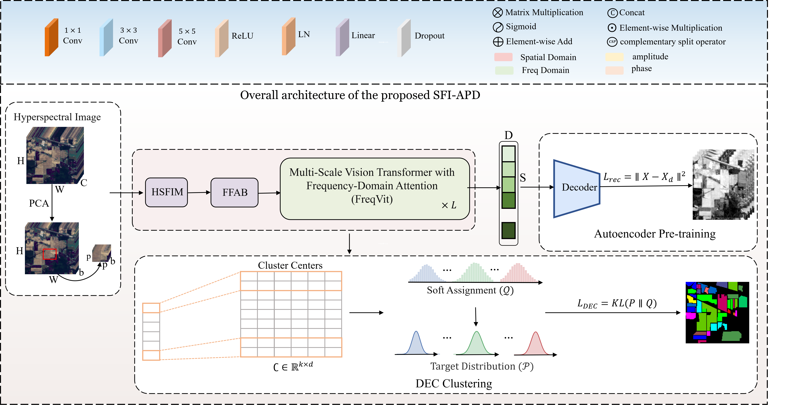
“Figure 1. Overall architecture of the SFI-APD framework. Firstly, the High-order space-frequency interactive module (HSFIM) was used to fuse the space-frequency features of the hyperspectral image after PCA dimension reduction. Then frequency feature Attention Block (FFAB) decouples the features fused with spatial-frequency information from amplitude and phase to suppress the spectral distortion caused by illumination and retain structural information. Finally, the Frequency Domain Vision Transformer (FreqViT) captures long-range dependencies under a self-supervised optimization strategy for feature representation learning with clustering optimization.”
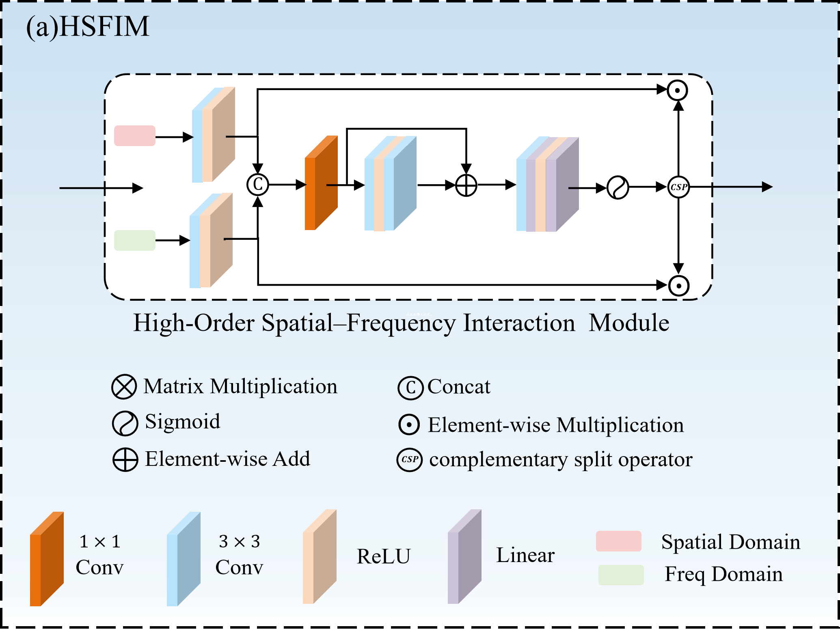
Figure 2. Detailed architecture of HSFIM

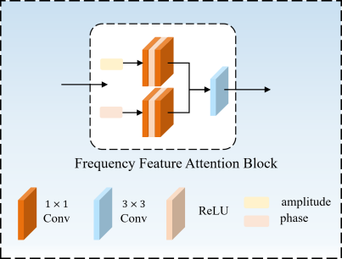
Figure 3. Detailed architecture of FFAB

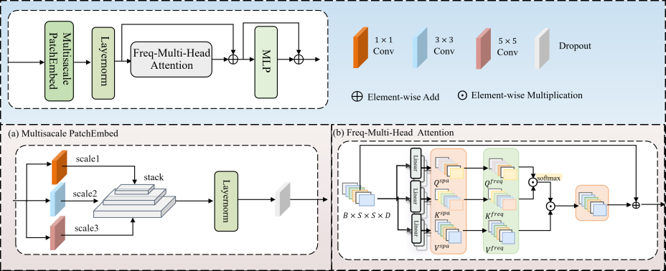
Figure 4. Detailed architecture of FreqViT

Comments 2: Why choose Fourier filtering for frequency-domain feature extraction?
Response 2: We sincerely thank the reviewer for raising the insightful question regarding the reasons for selecting Fourier filtering for frequency-domain feature extraction. The choice of Fast Fourier Transform, FFT, over other transformations, such as the Discrete Cosine Transform, DCT, or Discrete Wavelet Transform, DWT, is determined by the design requirements of the subsequent Frequency Feature Attention Block, FFAB. FFT extracts a complete complex-domain spectrum containing both amplitude and phase. Extracting both amplitude and phase is a core requirement for FFAB to decouple and suppress illumination-sensitive amplitude components while preserving structure-rich phase information. In contrast, DCT only outputs real-valued coefficients and lacks the explicit phase information required for amplitude and phase decoupling. Although DWT offers good time-frequency localization, multi-level subband decomposition and inverse reconstruction operations significantly increase computational complexity. Therefore, FFT provides an optimal balance between architectural simplicity and functional requirements.
To thoroughly validate the choice of FFT, we conducted an ablation study by replacing the FFT branch in HSFIM with four alternatives, including pure 3×3 spatial convolution, large-kernel 5×5 spatial convolution, DCT, and Haar-wavelet-based DWT. The FFT-based approach consistently demonstrated superior cross-scene generalization. On the Indian Pines, Salinas, and Yangzhou datasets, FFT significantly outperformed the other four methods in Overall Accuracy, OA. Specifically on the Yangzhou dataset, FFT achieved 64.11% OA, exceeding pure spatial convolution, large-kernel convolution, DCT, and DWT by 17.57%, 10.79%, 4.84%, and 5.14%. On the Pavia University dataset, FFT achieved 54.57% OA, outperforming pure spatial convolution, large-kernel convolution, DCT, and DWT by 4.85%, 3.78%, 0.95%, and 6.71%. FFT achieved much higher Adjusted Rand Index, ARI, 39.40% versus 34.11%, and Fowlkes-Mallows Index, FMI, 52.38% versus 48.07%, indicating a much more consistent clustering performance. The experimental results confirm that the performance gain results from the global frequency-domain feature representation rather than a simple increase in parameters or kernel size.
Based on the comprehensive analysis, we have incorporated the ablation study comparing different frequency-domain modeling methods into Section 4.4, along with the corresponding quantitative results presented in Table 11.
Location in the revised manuscript:
Section 4.4, “Comparison of Frequency-Domain Feature Extraction Strategies in HSFIM,” immediately after “Effectiveness of Multi-Scale Convolutional Embedding” and before “Phase Sensitivity Analysis of FreqViT.”in the main component ablation study.
Revised manuscript text:
“Comparison of Frequency-Domain Feature Extraction Strategies in HSFIM
Fourier filtering is crucial for HSFIM, as it simultaneously enables global feature aggregation and extracts the amplitude and phase information required by the subsequent FFAB. To verify its effectiveness, we compared our proposed learnable complex Fourier filtering (FFT) with four alternative strategies: (1) Spatial Conv, which retains only the 3×3 spatial convolution; (2) Large-kernel Conv, which uses a 5×5 convolution; (3) DCT, which applies learnable filtering to discrete cosine coefficients; and (4) DWT, which performs wavelet decomposition, learnable subband modulation, and inverse reconstruction. To ensure a fair comparison, only the feature extraction branch was modified while all other network components and training configurations remained strictly identical, with the quantitative results summarized in Table 11.
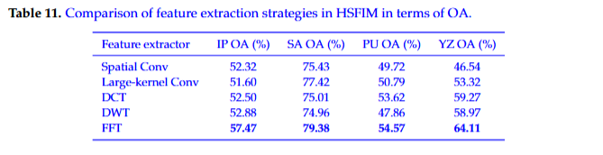
As shown in Table 11, FFT achieves the highest OA on all four datasets. Compared with Spatial Conv, Large-kernel Conv, DCT, and DWT, the OA gains of FFT range from 4.59% to 5.87% on Indian Pines, from 1.96% to 4.42% on Salinas, from 0.95% to 6.71% on Pavia University, and from 4.84% to 17.57% on Yangzhou. On the large-scale Yangzhou dataset, FFT exceeds Spatial Conv, Large-kernel Conv, DCT, and DWT by 17.57%, 10.79%, 4.84%, and 5.14%, respectively.
The quantitative comparison shows that effective feature extraction in HSFIM requires both full-image context modeling and amplitude–phase representation. Spatial Conv and Large-kernel Conv mainly capture local spatial patterns and focus primarily on short-range regional relationships. DCT represents global frequency information through cosine bases. FFT further preserves both amplitude and phase, matching the amplitude recalibration and phase preservation operations in FFAB. DWT focuses on localized multi-scale subbands and provides detailed local frequency features. By combining full-image frequency aggregation with amplitude–phase preservation, FFT achieves higher OA than the four alternative feature extractors on all datasets."

Comments 3: Please further introduce the meaning and importance of the evaluation indicators in Section 4.1.2.
Response 3:We sincerely thank the reviewer for the constructive suggestion. To provide a more comprehensive evaluation of the hyperspectral image clustering performance, we have expanded Section 4.1.2 to detail the meaning and significance of the selected evaluation metrics. Overall Accuracy (OA) measures the global clustering performance by calculating the proportion of correctly assigned pixels across the entire dataset. Because hyperspectral datasets often exhibit severe class imbalance, OA is easily dominated by majority classes. To address the class imbalance issue, Average Accuracy (AA) is utilized. AA calculates the mean accuracy across all individual categories, ensuring minority classes receive equal representation in the performance assessment. The Kappa coefficient evaluates the agreement between the clustering map and the ground truth while penalizing random chance agreements, thereby ensuring the statistical reliability of the evaluation. Furthermore, Normalized Mutual Information (NMI) measures the mutual dependence between the predicted cluster assignments and the ground truth labels from an information-theoretic perspective. NMI is particularly crucial for unsupervised clustering tasks because NMI evaluates the structural consistency of the partitions independent of absolute label permutations. Finally, to analyze category-specific segmentation errors, Producer Accuracy (PA), and User Accuracy (UA) are included. PA quantifies the omission error by measuring the proportion of actual pixels of a specific class correctly identified by the model. UA quantifies the commission error by calculating the ratio of correctly classified pixels in a specific category to the total number of pixels predicted as the specific category. Integrating OA, AA, Kappa, NMI, PA, and UA enables a multi-dimensional evaluation covering global accuracy, class balance, statistical reliability, information-theoretic structural similarity, and fine-grained error analysis. The detailed definitions and the rationale for selecting the evaluation metrics have been incorporated into Section 4.1.2 of the revised manuscript.
Location in the revised manuscript: Section 4.1.2 (Evaluation Metrics), replacing the original one-sentence metric list.
Revised manuscript text:
“Quantitative evaluation methods include overall accuracy (OA), mean accuracy (AA), Kappa coefficient, adjusted Rand index (ARI), adjusted mutual information (AMI), normalized mutual information (NMI), homogeneity, completeness, V-measure and Fowlkes-Mallows index (FMI). Producer precision (PA) and user precision (UA) in order to provide category analysis.
In order to comprehensively evaluate the performance of unsupervised clustering of hyperspectral images, this paper focuses on overall accuracy (OA), mean average accuracy (AA), Kappa coefficient and normalized mutual information (NMI) as the main evaluation indicators, supplemented by producer Accuracy (PA) and user accuracy (UA) for more in-depth category analysis. Since the cluster labels assigned by unsupervised clustering are random during training, the predicted cluster labels are aligned with the reference true labels by optimal one-to-one matching, such as the Hungarian algorithm, before calculating the above classification accuracy based metrics.
The selected evaluation metrics comprehensively reflect the clustering effect of the model from multiple complementary dimensions. OA intuitively measures the global clustering accuracy, but the calculation results are easily dominated by large-sample categories. AA assigns the same weight to each class, reflecting the model performance on minority classes and small-sample representative features more fairly. Combining OA and AA effectively evaluates the balance between overall accuracy and class-level performance. The Kappa coefficient further eliminates the bias caused by chance consistency, providing a more objective evaluation of the reliability of the clustering results.Unlike accuracy metrics requiring label matching, NMI directly measures the structural consistency between the predicted partition and the reference label from an information-theoretic perspective. NMI also remains permutation invariant to the cluster label index. Finally, introducing PA and UA allows for a detailed examination of category-specific segmentation errors. PA quantifies missed classifications, and UA quantifies misclassifications. Analyzing PA and UA together comprehensively evaluates the effectiveness and robustness of the clustering results.”
Comments 4: Some indicators in Table 6 are inferior. How can this phenomenon be explained?
Response 4:We sincerely thank the reviewer for the careful observation regarding the experimental results in Table 6. SFI-APD yields slightly lower values in Overall Accuracy, Homogeneity, and Completeness than the top-performing methods. These differences mainly reflect inherent trade-offs among clustering metrics, further amplified by severe class imbalance in hyperspectral datasets. Following the reviewer’s suggestion, we have added an analysis of the trade-offs among the evaluation metrics in Table 6 to the revised manuscript. The Overall Accuracy metric is heavily dominated by large-area categories, such as Asphalt and Meadows. Using Overall Accuracy (OA) alone may obscure poor clustering performance in minority categories under severe class imbalance. For instance, DCN attains slightly higher OA by favoring majority classes. However, the Average Accuracy (AA) of DCN is markedly lower than the AA of SFI-APD. In contrast, SFI-APD promotes more balanced feature representation across categories, resulting in improved AA and demonstrating stronger generalization across varying spatial scales. In addition, a trade-off exists between Homogeneity and Completeness. High Homogeneity is often associated with class fragmentation, as observed in DSASC, whereas high Completeness tends to indicate category merging, as seen in DEKM. SFI-APD achieves the best Adjusted Rand Index and Fowlkes–Mallows Index, reaching 39.40% and 52.38%, demonstrating strong pairwise clustering stability and competitive balance between Homogeneity and Completeness.
Consistent with the quantitative results, the clustering map in Fig. 7(k) shows that SFI-APD preserves the main road network and large homogeneous regions, with minor confusion in spectrally similar and shadowed areas.The results indicate that the slight reductions in Overall Accuracy, Homogeneity, and Completeness arise from local class merging or fragmentation in challenging regions rather than a general loss of spatial structure. SFI-APD successfully balances the aforementioned trade-offs by achieving the highest scores in comprehensive metrics, including Adjusted Rand Index, Adjusted Mutual Information, Normalized Mutual Information, V-measure, and Fowlkes–Mallows Index. The superior performance in the comprehensive metrics proves SFI-APD maintains an optimal balance between cluster purity and category integrity. And the existing literature on hyperspectral image clustering confirms the difficulty of maximizing all evaluation metrics simultaneously due to complex spectral mixing and fuzzy category boundaries. The comprehensive results in Table 6 validate the robust, balanced, and highly consistent clustering capability of the proposed SFI-APD.

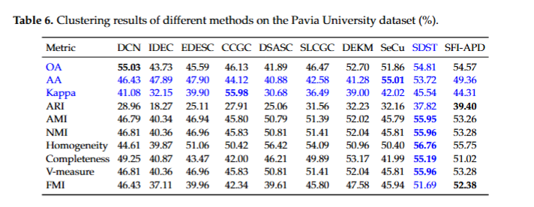
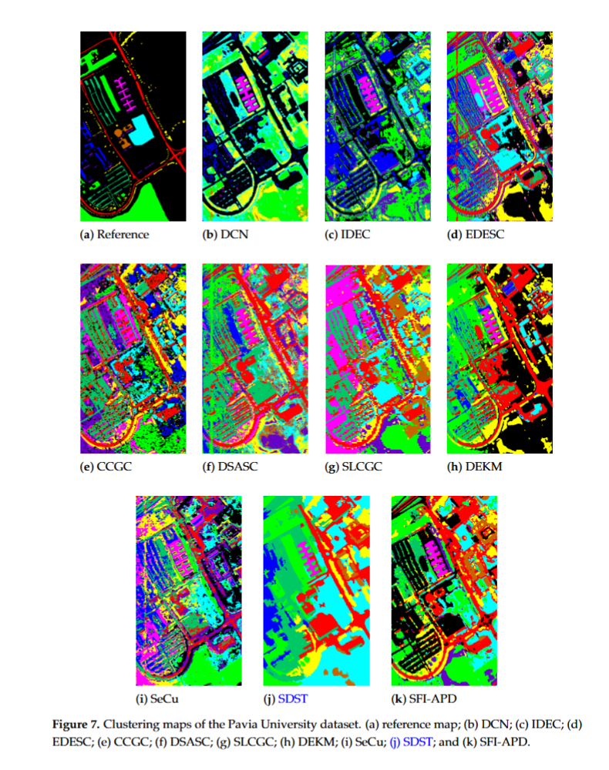

References:
[1] H. Jiang, Q. Gao, H. Chen, and B. Zhou, “Center-Pixel Guided Dual-Path Multihead Attention Fusion Transformer for Hyperspectral Image Classification,” IEEE Transactions on Geoscience and Remote Sensing, vol. 64, Art. no. 5505918, pp. 1–18, 2026, doi: 10.1109/TGRS.2026.3662353.
[2] F. Luo, Y. Liu, Y. Duan, T. Guo, L. Zhang, and B. Du, “SDST: Self-Supervised Double-Structure Transformer for Hyperspectral Images Clustering,” IEEE Transactions on Geoscience and Remote Sensing, vol. 62, Art. no. 5511614, pp. 1–14, 2024, doi: 10.1109/TGRS.2024.3374597.
Location in the revised manuscript:
Section IV.B, “Results on Pavia University,” immediately after the quantitative analysis of Table 6 and before the class-wise clustering performance analysis and discussion of Fig. 7.
Revised manuscript text:
“The slightly lower values of SFI-APD on several individual metrics reflect differences in evaluation priorities. Since OA naturally favors dominant classes, DCN achieves a marginally higher OA (55.03%) by covering large Asphalt and Meadows regions, but yields an AA 2.93% lower than SFI-APD. Furthermore, Homogeneity and Completeness present a strict trade-off. Extremely high Homogeneity typically reflects class fragmentation. Extremely high Completeness often indicates excessive category merging. SFI-APD successfully balances the trade-off between Homogeneity and Completeness, yielding reliable structural assignments confirmed by superior ARI and FMI scores. Despite not achieving the absolute highest Homogeneity or Completeness, SFI-APD obtains the best ARI (39.40%) and FMI (52.38%), indicating robust clustering coupled with competitive performance across other metrics.”

